**MANAV RACHNA INTERNATIONAL**

**INSTITUTE OF RESEARCH AND STUDIES**



**FACULTY OF COMPUTER APPLICATIONS**

PRACTICAL FILE

OF

ORACLE LAB

# BCA 5th SEM-SECTION D (2024-2025)

**SUBMITTED TO: SUBMITTED BY:**

Ms. NEERJA NEGI **NAME:** AMAN BAGHEL

# **ROLL NO:**22/FCA/BCA(CS)/050

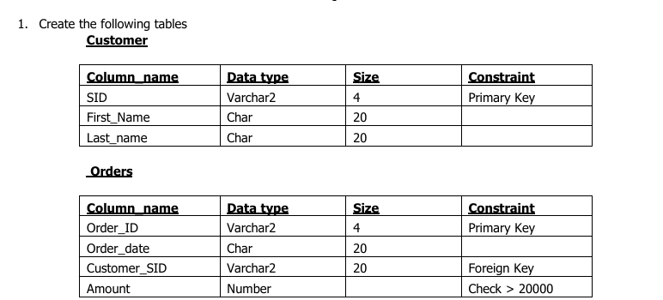

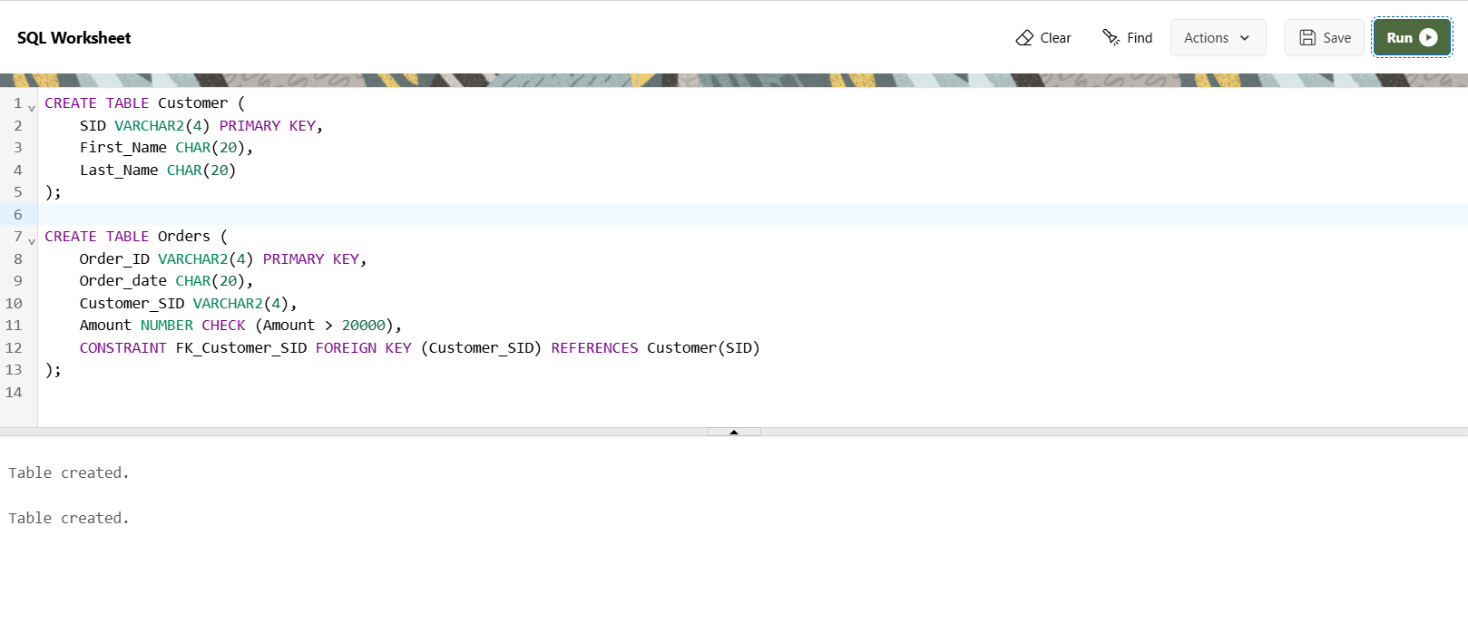

2. Insert five records for each table.

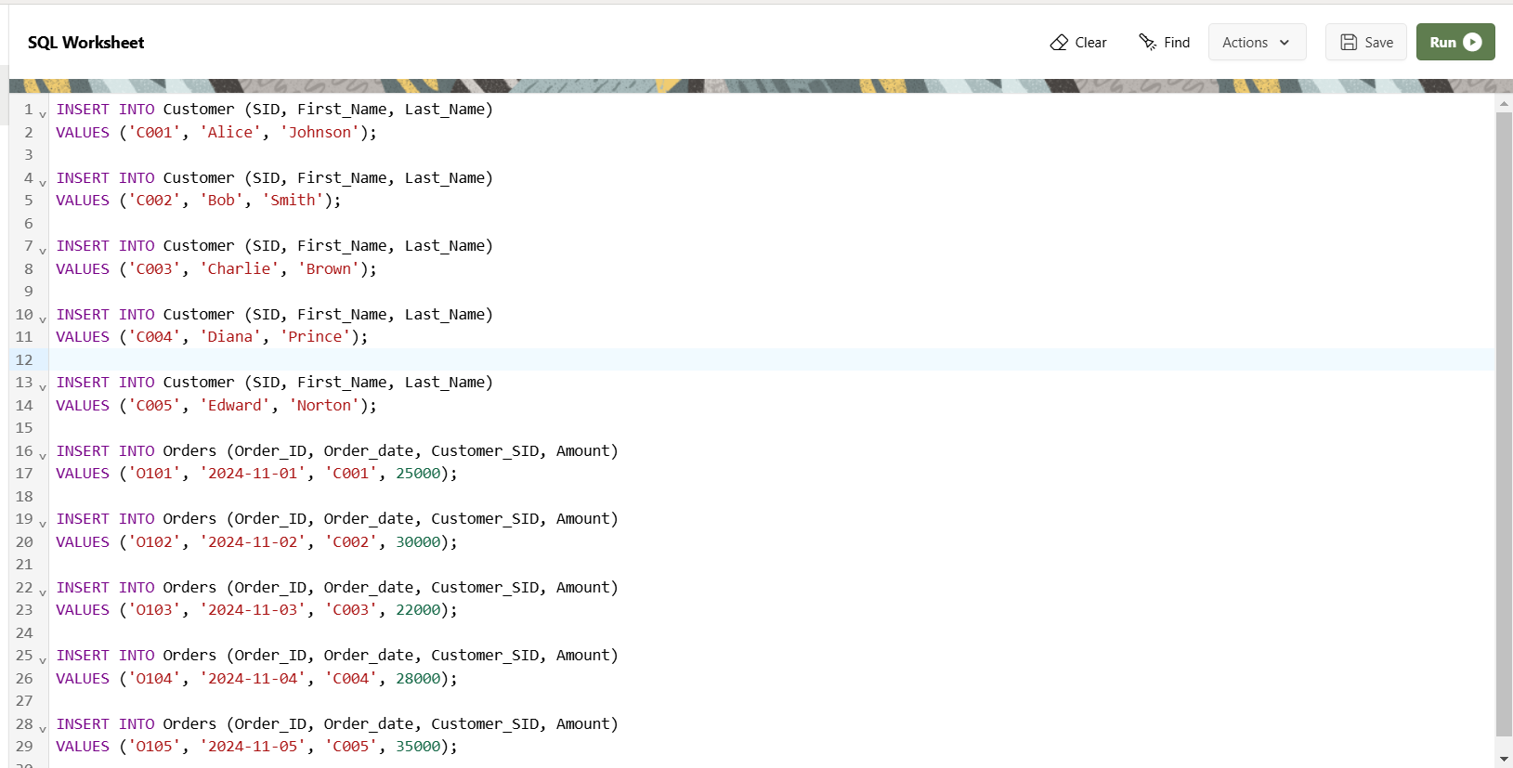

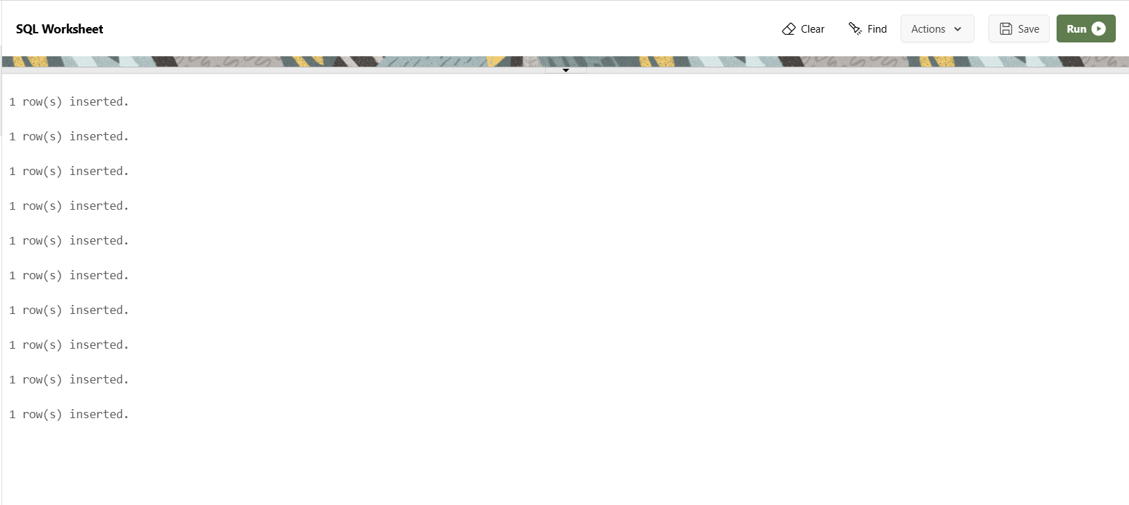

3. Customer_SID column in the ORDERS table is a foreign key pointing to the SID column in the CUSTOMER table.



4. Insert five records for both tables

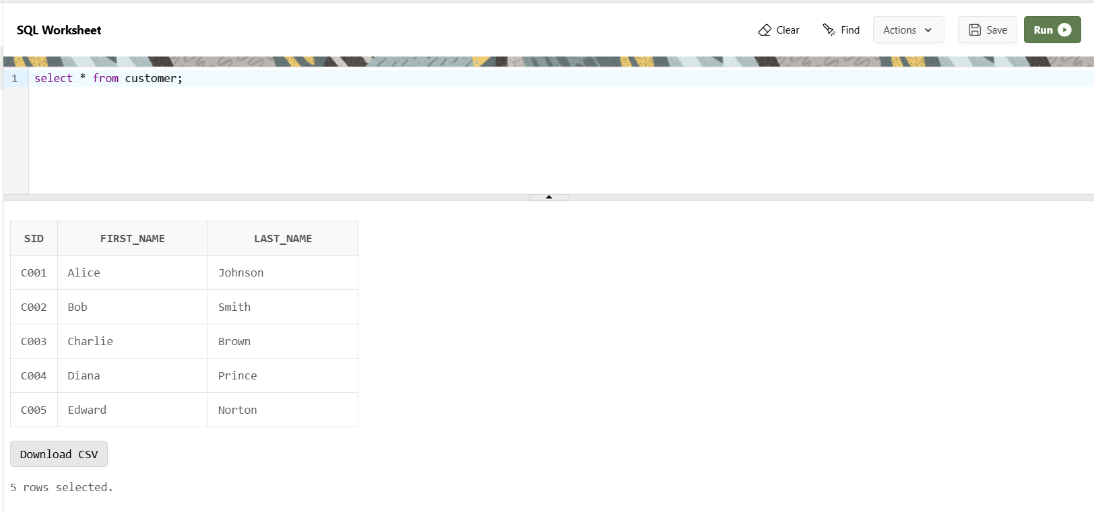

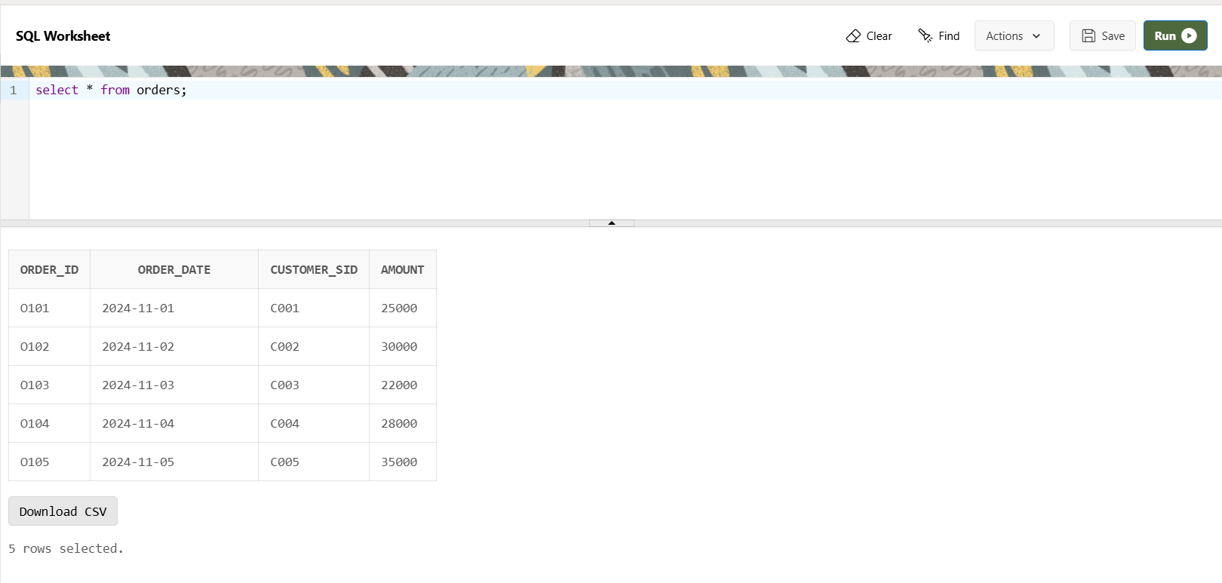

5. List the details of the customers along with the amount.

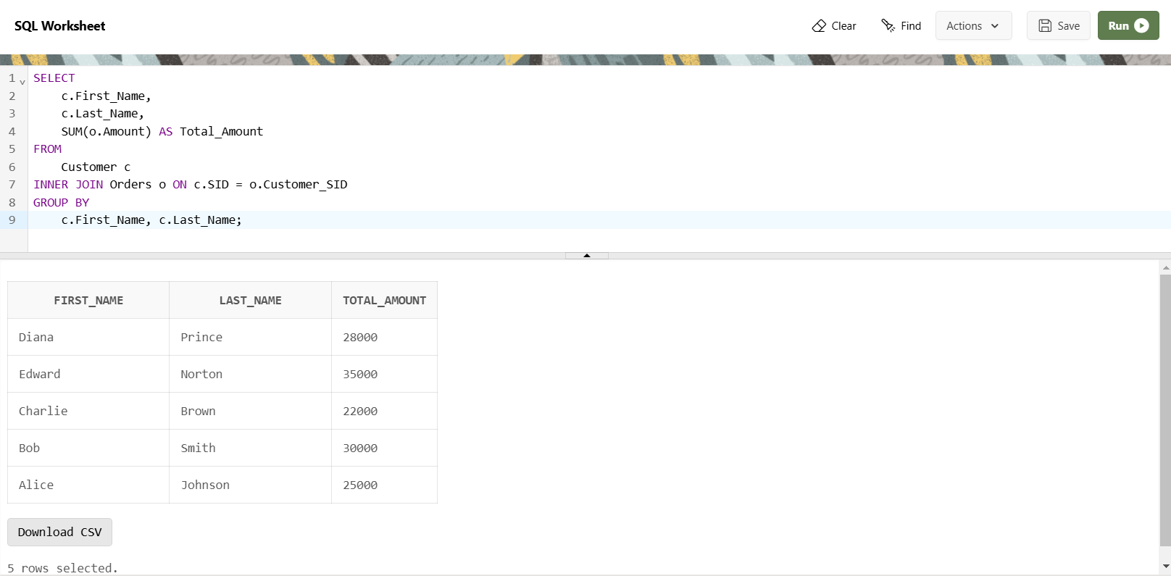

6. List the customers whose names end with “s”.

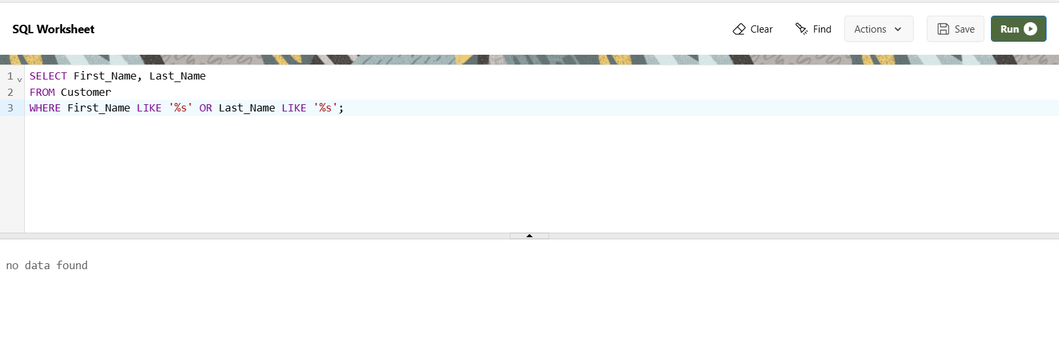

7. List the orders where amount is between 21000 and 30000

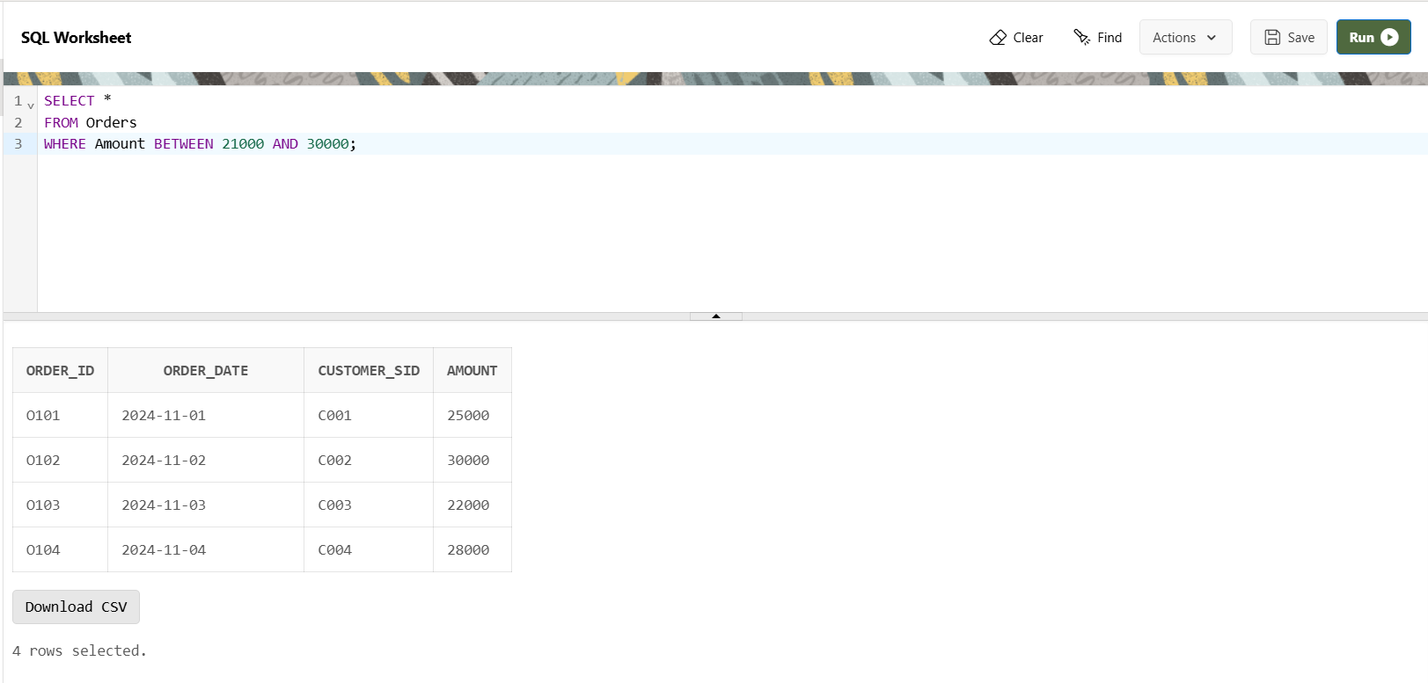

8. List the orders where amount is increased by 500 and replace with name “new amount”.

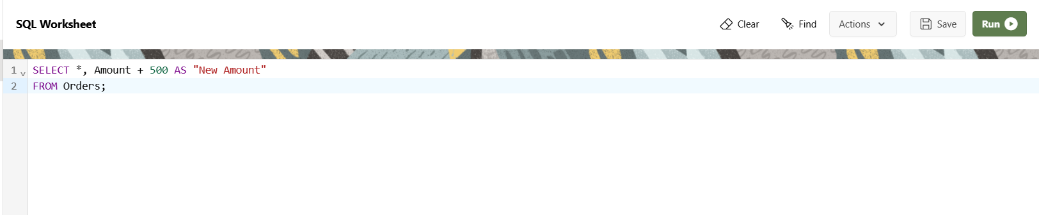

9. Display the order_id and total amount of orders

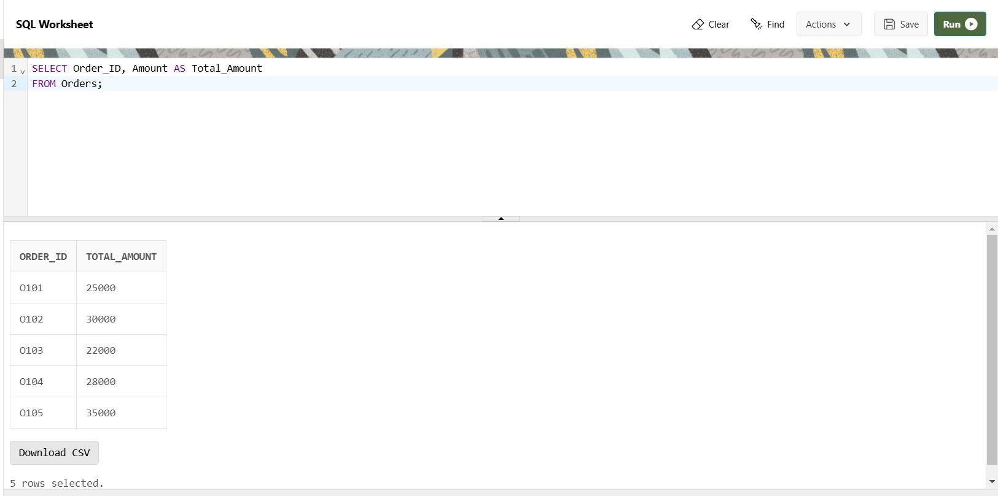

10. Calculate the total amount of orders that has more than 15000.

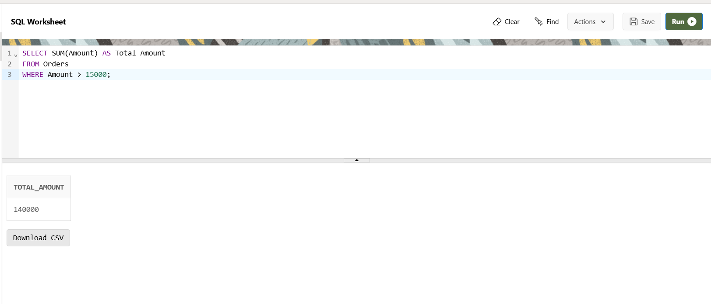

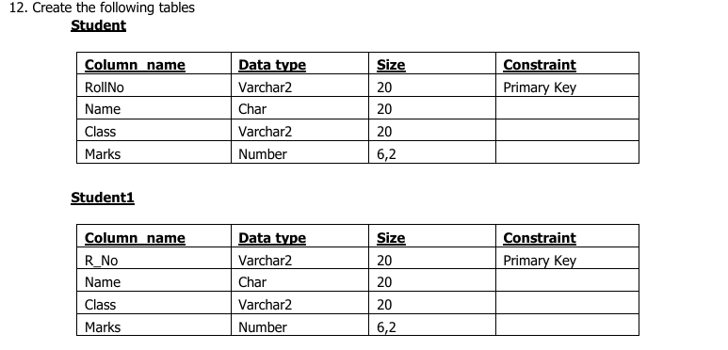

13. Display all the contents of student and student1 using union clause.

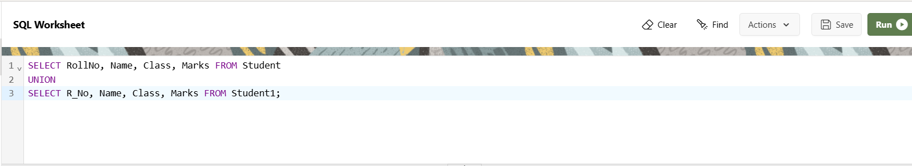

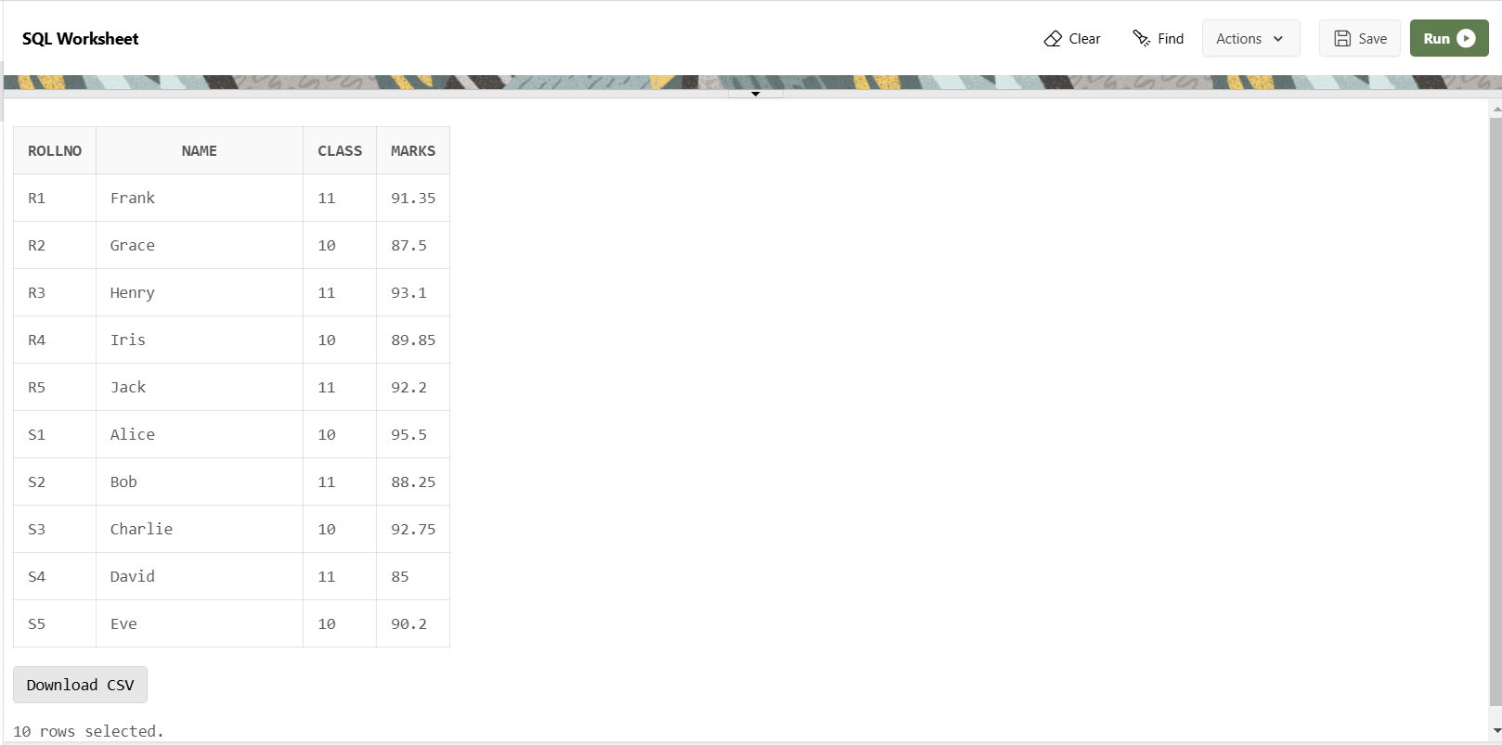

14. Find out the intersection of student and student1 tables.

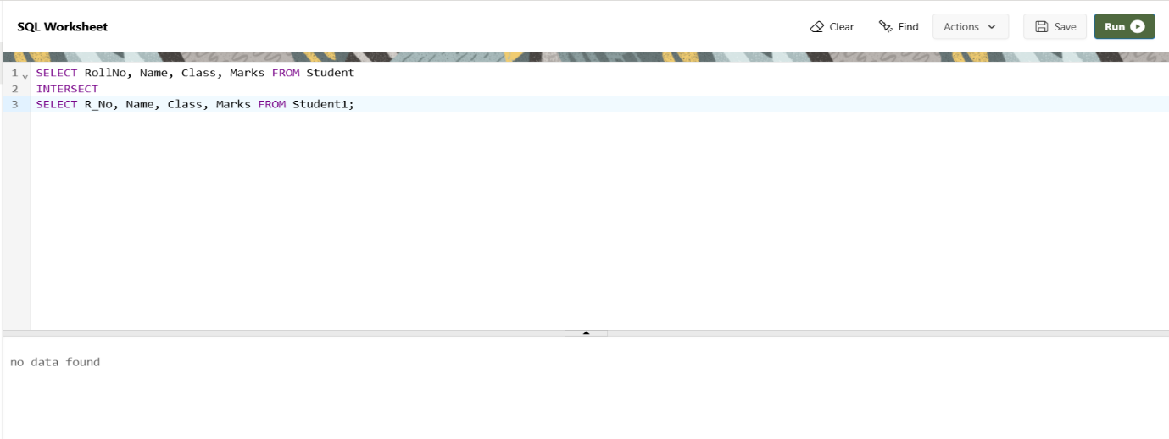

15. Display the names of student and student1 tables using left, right ,inner and full join.

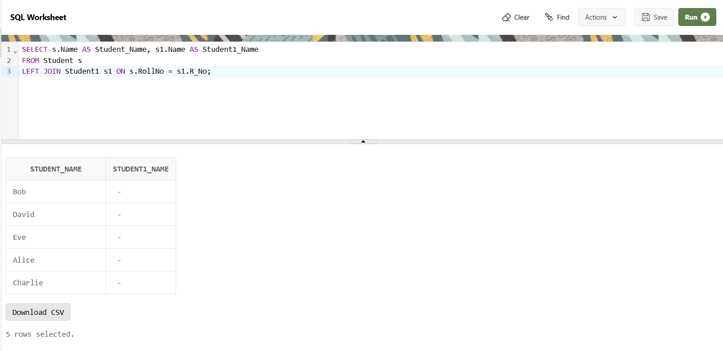

16. Write a PL/SQL block to calculate total salary of employee having employee number 100.

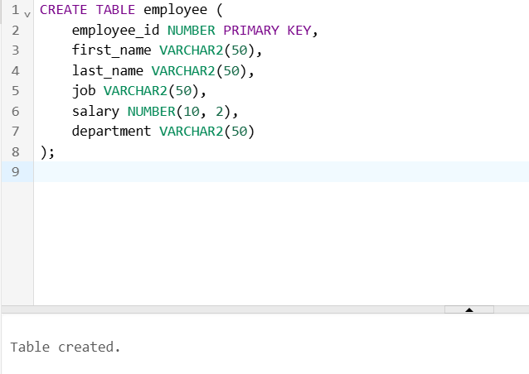

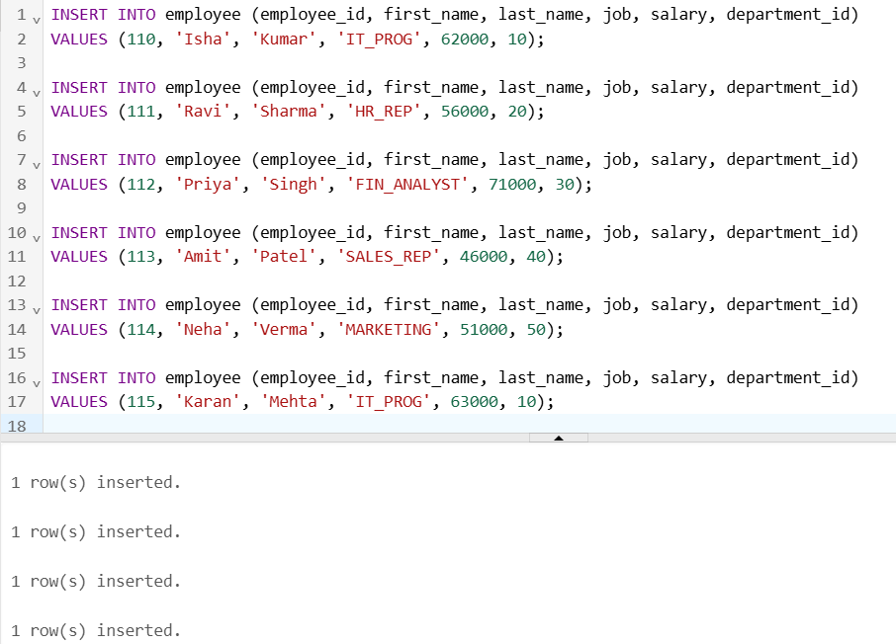

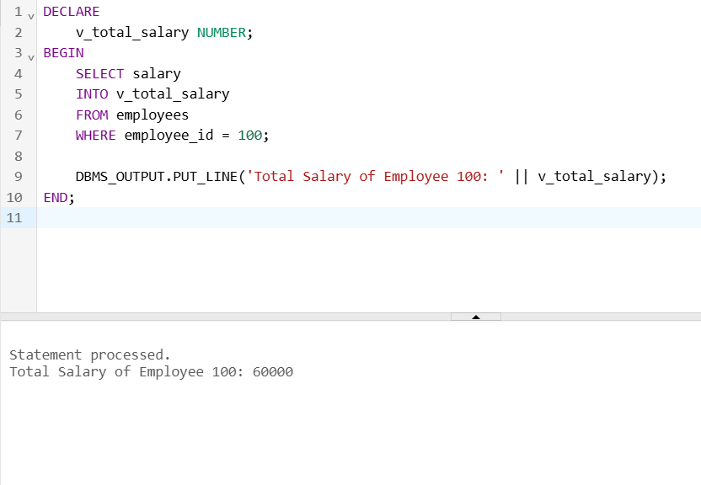

17. Write a PL/SQL code to find the greatest of three numbers.

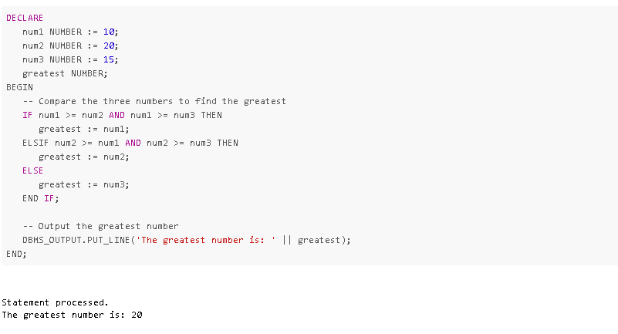

18. Write a PL/SQL code to print the numbers from 1 to n.

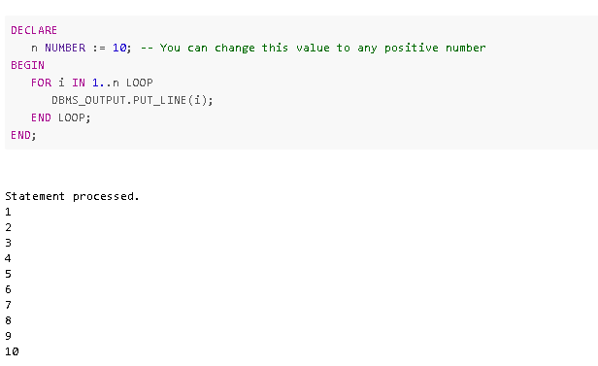

19. Write a PL/SQL code to reverse a string using for loop.

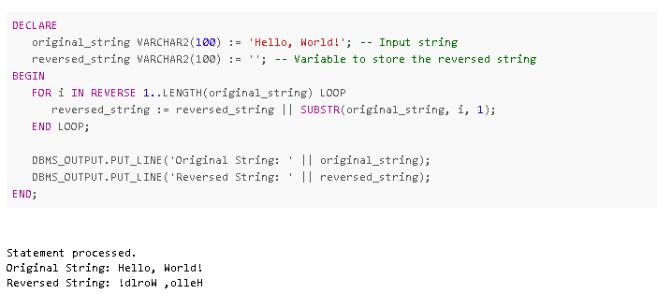

20. Write a PL/SQL code to find the sum of n numbers.

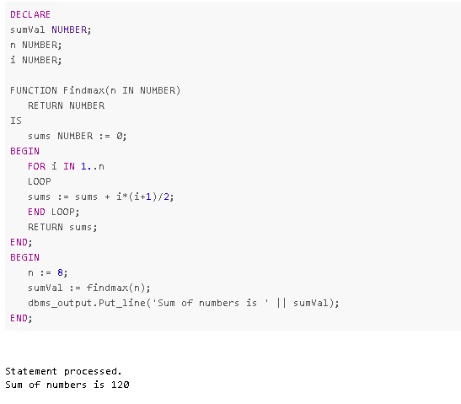

21. Consider a PL/SQL code to display the empno, ename, job of employees of department number 10.

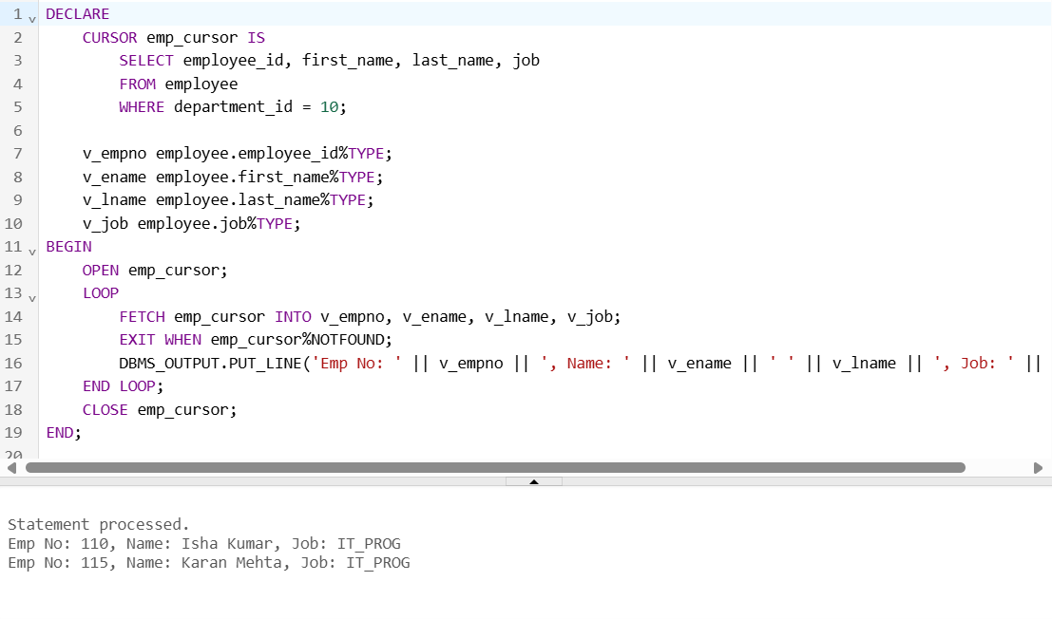

22. Consider a PL/SQL code to display the employee number & name of top five highest paid employees.

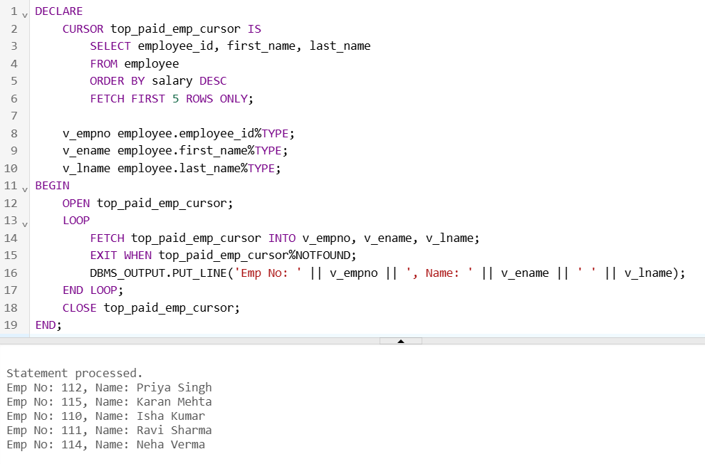

23. Consider a PL/SQL procedure that accepts 2 numbers & return addition, subtraction, multiplication & division of two numbers using stored procedure AND local procedure.

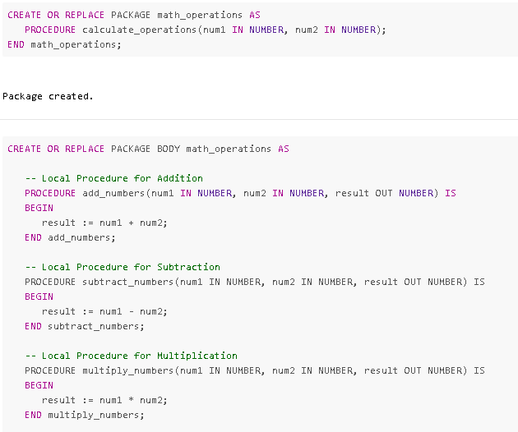

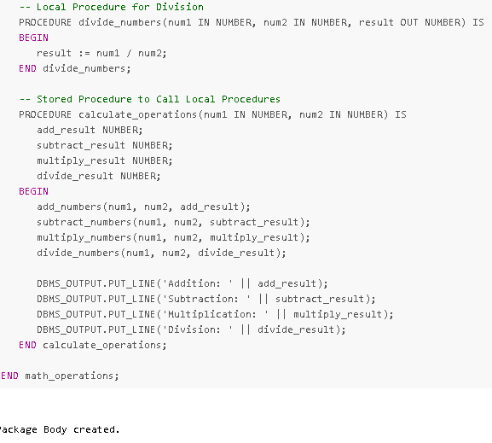

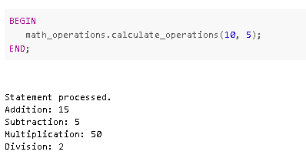

24. Consider a PL/SQL code that accepts 2 numbers & return addition, subtraction, multiplication & division of two numbers using stored functions and local function.

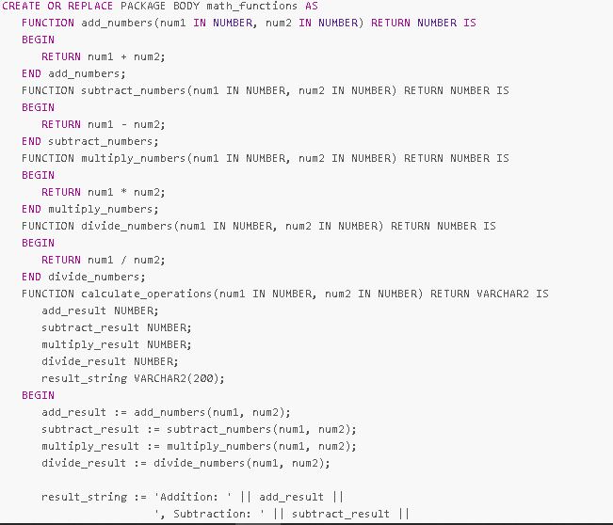

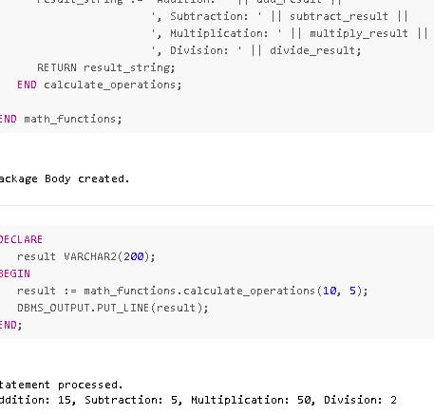

25. Write a PL/SQL block to show the use of NO_DATA FOUND exception.

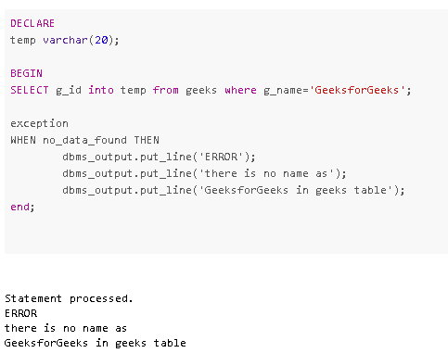

26. Write a PL/SQL block to show the use of TOO_MANY ROWS exception.

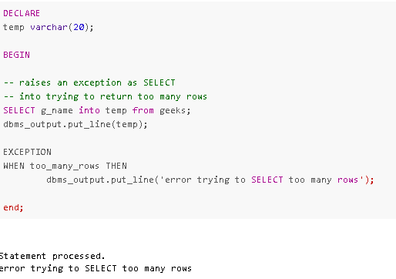

27. Write a PL/SQL block to show the use of ZERO_DIVIDE exception.

